**Team 33**

**Omar Hatem Abdelshafy**

**Abelrahman Atef**

**Omar Ahmed**

**Shimaa Mohamed Abdallah**

**Doaa Hesham**

**Abstract**

**This project is a desktop application for restaurant system.**

**There are two main layouts, one for the customer and another one for the admin.**

**The customer can see the menu and offers, he can choose the order to be indoor or takeaway.**

**The admin can update the menu whether by adding new items or delete already existing ones.**

**Table of contents**

**1.Introduction**

**1.1 purpose**

**1.2 list of definitions**

**1.3 Scope**

**1.4 overview**

**2. General description**

**2.1 product prospective**

**2.2 general capabilities**

**2.3 general constraints**

**2.4 user characteristics**

**2.5 environment description**

**2.6 Assumptions and dependencies**

**2.7 other resources needed**

**3. System Requirements**

**3.1 Functional requirements**

**3.2 Non-functional requirements**

**4. Use-Case Diagram**

**5. Narrative description**

**6. Requirements validation**

**7. Class model**

**8. State Diagram**

**9. Interaction Diagram**

**10. Detailed Class Diagram**

**11. User Interface design**

**12. Client-object relation diagram**

**13. Detailed Design**

**14. Testing**

**15. Estimated Project Cost.**

**16. User Guide**

**1. Introduction**

**1.1 Purpose**

After reading this documentation you should be aware of our system and all the attributes on it and how to deal with this system.

|  |  |
| --- | --- |
| Term | Description |
| Item | Single serving of food/beverage |
| Order | Comprises one or more items |
| Customer | Restaurant patron that orders/pays for a meal |
| admin | General restaurant employee |
| Waiter | Staff member whose primary job is to take orders/serve meals to customers |
| Chef | Staff member whose primary job is to prepare items |
| Table | Comprises one or more seats at which customers sit and place orders from |
| Payment | Comprises the total cost of zero or more meals and zero or more tips |
| Tablet | Wireless mobile computer to provide staff with customer serving functionality |
| Menu | Surface computer representation of the available items and other options |
| RMS | Restaurant management system |

**1.2 List of definitions**

**1.3 Scope**

Our project is a desktop application which serves the people to check menu and the newest orders and validation time of it and customer can make order via the system, check the cost of the order, check empty tables, the customer receive feedback application to fill it before paying the cost of the orders.

**1.4 Overview**

The Restaurant Menu and Ordering System is a software package to facilitate ordering within a traditional restaurant. The customer is able to view the menu, place orders.

Then the admin checks the order, send orders to food preparation staff and finalize the customer’s order, Customers are presented with an attractive and easy-to-use surface computer GUI with a drag-and drop ‘object’ metaphor in their menus, so in the event of a customer being unable to operate the surface computer, the waiter can handle orders traditionally while using retaining the accountability and logging functions of the system, and retaining the same channel of communication with food staff.

**2. General Description**

**2.1 Product Perspective**

The restaurant management system helps the restaurant manager to manage the restaurant more effectively by checking the number of orders and the time of each order so he could know the intervals with so much customers to decide if whether more waiters or chefs are needs.

**2.2 General Capabilities**

(check menu – check offers - make order – check tables – check the cost – payment – make review)

**2.3 General Constraints**

The software that is developed covers only the aspect of check offers and menus, food ordering, payments, taking the order indoor or outdoor and making feedback.

**2.4 User Characteristics**

The restaurant management system has two active actors and one cooperating system.

The customer can access the system through the application and order food.

The admin gets the order and gives the order to the chef to make it and then the waiter takes the order to the customer if the order “indoor” otherwise the delivery man would take the order.

**2.5 Environment Description**

Operating system: Minimum windows XP or windows VISTA.

Better environment windows 7, 8, 9, 10.

Language: Java.

**2.6 Assumptions and Dependencies**

If this RMS has IOS and Windows app then customers who use such kind of smartphones will be more benefited. If there are more Tablets for each table, the whole system performance will be better.

**2.7 Other resources needed**

**Scene builder, IntelliJ IDE, Java11 with java sdk, Java FX library.**

**3. System requirements**

**Functional requirements :**

1- User can order the food

2- System can calculate the total payment including fees

3- Client can order his food in the restaurant

4- Client can order food takeaway

5- User can view menu with available food

6- User can view latest offers

7- User can see available tables

8- User can know when will the food be ready

**Non functional requirements:**

9- System should be implemented within month

10- System should be reliable

11- System should recover within 20 secs

**4. Use case diagram**

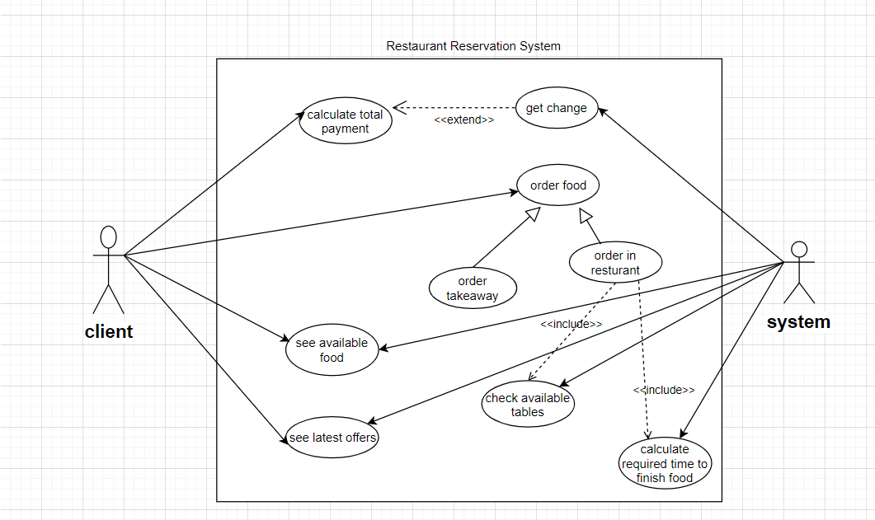

**5. Narrative description**

1-Calculate total payment

* **Use case name** **:** calculate total payment
* **Related requirements :** req2
* **Goal in context :** client can see the total payment for his order
* **Pre conditions :** check price of each selected item
* **Successful end condition :** total payment calculated successfully
* **Failed end condition :** total payment not calculated
* **Primary actor :** client
* **Secondary actor :** system
* **Trigger :** client would like to calculate the total payment for his order
* **Main flow :** - Client would like to calculate the total

price for his order

* System checks the selected items
* Checking the price of each selected items with the quantity of each then calculate the total price
* **Extensions :** 
  + - * client can get change

2- Get change

* **Use case name** **:** get change
* **Related requirements :** req2
* **Goal in context :** client can get change
* **Pre conditions :** check amount of money needed to get changed
* **Successful end condition :** client get the change
* **Failed end condition :** client didn’t get change
* **Primary actor :** client
* **Secondary actor :** system
* **Trigger :** System subtracts the paid amount from the order total amount and check if there’s change
* **Main flow:** -Clients pays for his order
* System calculate the amount of money to return back

3- Order food

* **Use case name** **:** order food
* **Related requirements :** req1
* **Goal in context :** Client order food
* **Pre conditions :** Client login to the app
* **Successful end condition :** Client successfully make order
* **Failed end condition :** Client couldn’t make order
* **Primary actor :** Client
* **Secondary actor :** System
* **Trigger :** Humans’ desire to eat
* **Main flow :** - Client Want to order food
* Client login to the app
* Client make an order
* Client choose Indoor or Takeaway order
* **Extensions :** 
  + - * Order takeaway
      * Order in Restaurant

4- Order takeaway

* **Use case name** **:** order takeaway
* **Related requirements :** req4
* **Goal in context :** Client place a takeaway order
* **Pre conditions :** Client successfully added desired items to the shopping menu
* **Successful end condition :** Client Placed a takeaway order
* **Failed end condition :** Client couldn’t place order
* **Primary actor :** Client
* **Secondary actor :** System
* **Trigger :** Client want to place a takeaway order
* **Main flow :** 
  + - * Client Choose desired items to the shopping list
      * Client specify quantity of each item
      * Client choose the takeaway option
* **Include :** Order food

5- Order in restaurant

* **Use case name** **:** order in restaurant
* **Related requirements :** req3
* **Goal in context :** Client place an indoor order
* **Pre conditions :** Client successfully added desired items to the shopping menu
* **Successful end condition :** Client Placed an indoor order
* **Failed end condition :** Client couldn’t place order
* **Primary actor :** Client
* **Secondary actor :** System
* **Trigger :** Client want to place a takeaway order
* **Main flow :**
  + - * Client Choose desired items to the shopping list
      * Client specify quantity of each item
      * Client choose the indoor option
* **Include :** Order food

6- See available food

* **Use case name** **:** see available food
* **Related requirements :** req5
* **Goal in context :** Client Browse the menu
* **Pre conditions :** Client login into app
* **Successful end condition :** Client see the menu
* **Failed end condition :** Client couldn’t see the menu
* **Primary actor :** Client
* **Secondary actor :** System
* **Trigger :** Client want to order food
* **Main flow :**
  + - * Client open the app and login
      * Client browse the menu to place order
* **Extensions :** Client see the latest offers

7- See latest offers

* **Use case name** **:** see latest offers
* **Related requirements :** req6
* **Goal in context :** Client see the latest offers
* **Pre conditions :** Client logged into the app and browsing menu
* **Successful end condition :**  Client see the offers
* **Failed end condition:** Client couldn’t see the latest offers
* **Primary actor :** Client
* **Secondary actor :** System
* **Trigger :** Browsing menu
* **Main flow :** 
  + - * Client open the app and log in
      * Client start browsing the menu
      * Client see the latest offers
* **Include :** Browsing menu

8- Check available tables

* **Use case name** **:** check available tables
* **Related requirements :** req7
* **Goal in context :** Client choose a table
* **Pre conditions :** Indoor order chosen
* **Successful end condition :** Client see available tables and choose one
* **Failed end condition :** Client couldn’t see available tables
* **Primary actor :** Client
* **Secondary actor :** System
* **Trigger :** Client placed indoor orders
* **Main flow :**
  + - * Client make a shopping list
      * Client choose indoor order
      * Client see available table and choose one
* **Include :** Indoor prder

9- Calculate required time to finish food

* **Use case name** **:** calculate required time to finish food
* **Related requirements :** req8
* **Goal in context :** Calculate the time till order be ready
* **Pre conditions :** Client placed an order
* **Successful end condition :** Client see the estimated time
* **Failed end condition :** Client couldn’t see the estimated time
* **Primary actor :** System
* **Secondary actor :** Client
* **Trigger :** Client finished placing order
* **Main flow :** 
  + - * Client placed order
      * Client chose indoor or takeaway
      * Client see the estimated time till order is ready
* **Include :** Client placed an order

**6. Requirements Validation**

|  |  |  |  |  |  |
| --- | --- | --- | --- | --- | --- |
| **Executive manager** | **Project manager** | **Developer** | **Admin** | **Client** |  |
|  |  |  | ✓ | ✓ | **Req1** |
|  |  | ✓ | ✓ |  | **Req2** |
|  |  |  | ✓ | ✓ | **Req3** |
|  |  |  | ✓ | ✓ | **Req4** |
|  |  |  | ✓ | ✓ | **Req5** |
|  |  |  | ✓ | ✓ | **Req6** |
|  |  |  | ✓ | ✓ | **Req7** |
|  |  |  | ✓ | ✓ | **Req8** |
| ✓ |  |  |  |  | **Req9** |
|  | ✓ | ✓ |  |  | **Req10** |
|  | ✓ | ✓ |  |  | **Req11** |

**7. Class Model**

CRC cards

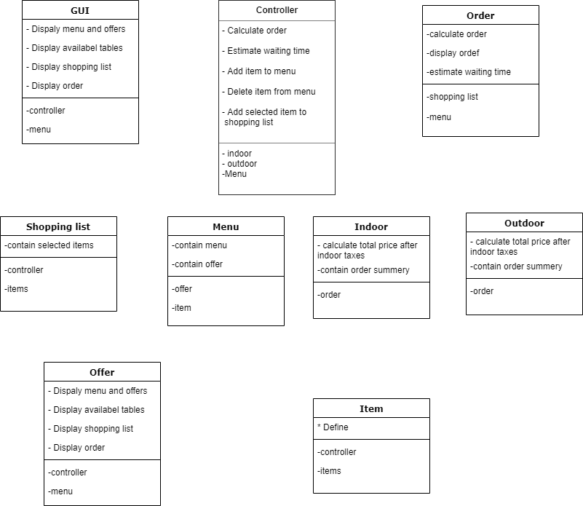

**Class diagram**

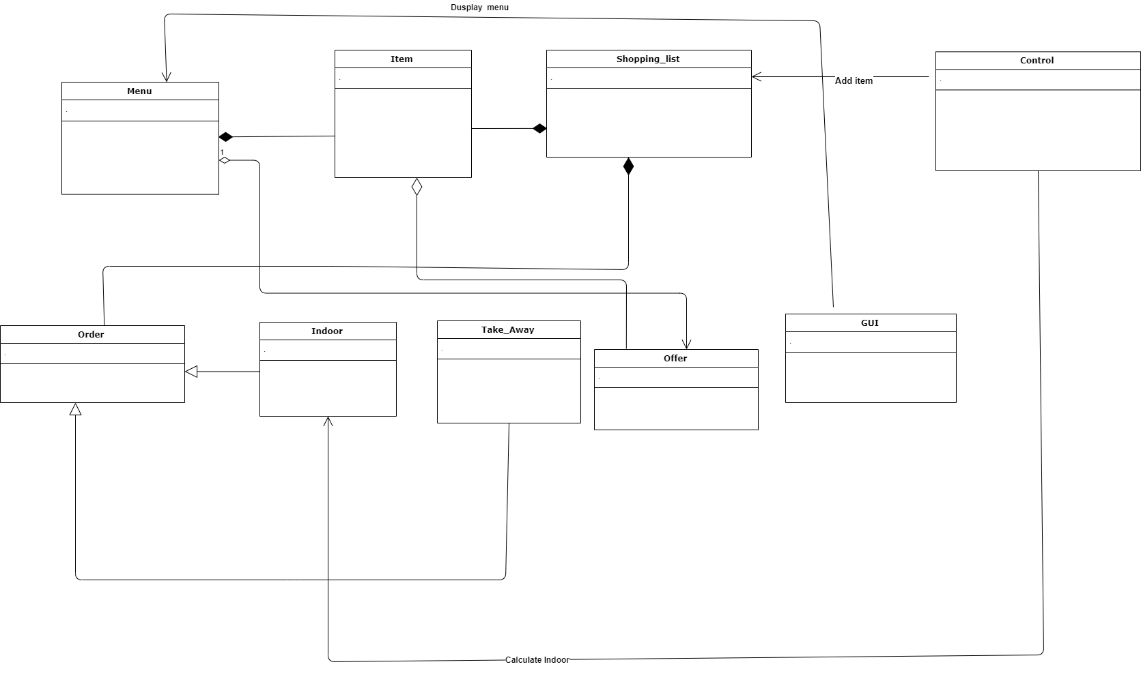

**8. State diagram**

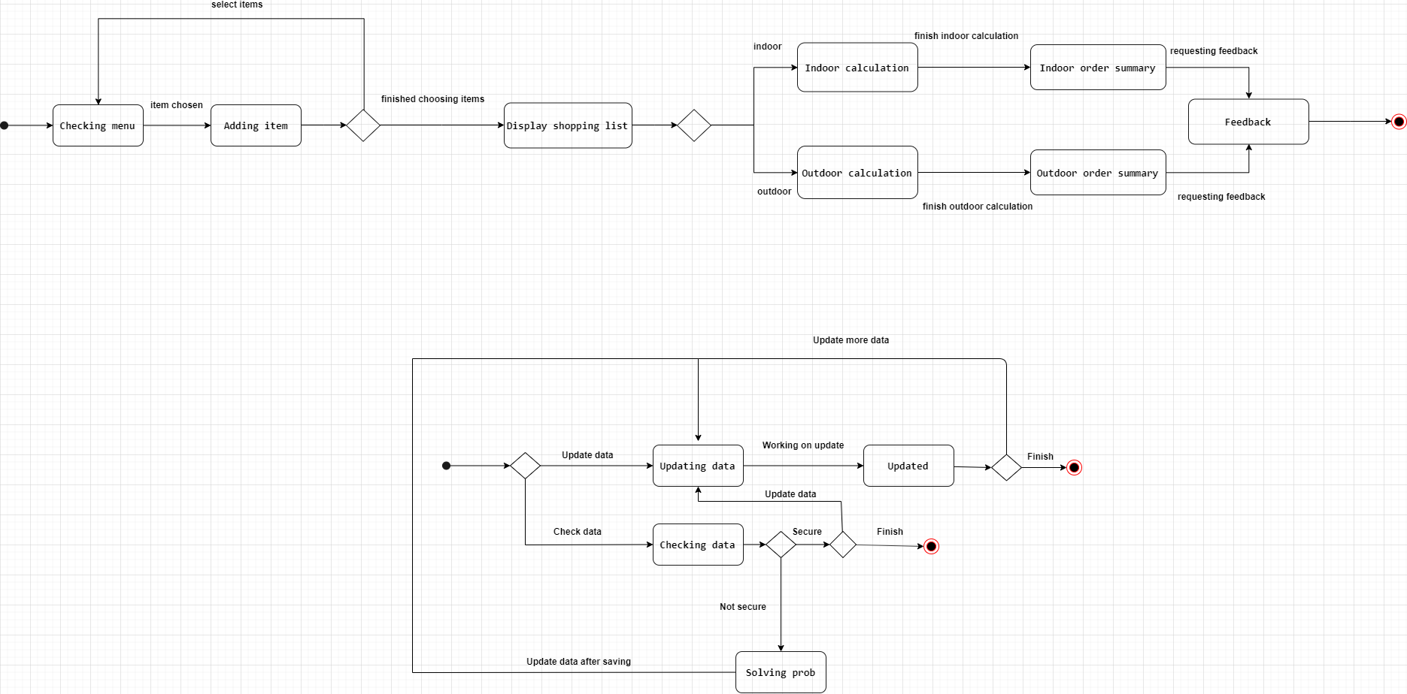

**9. Sequence diagram**

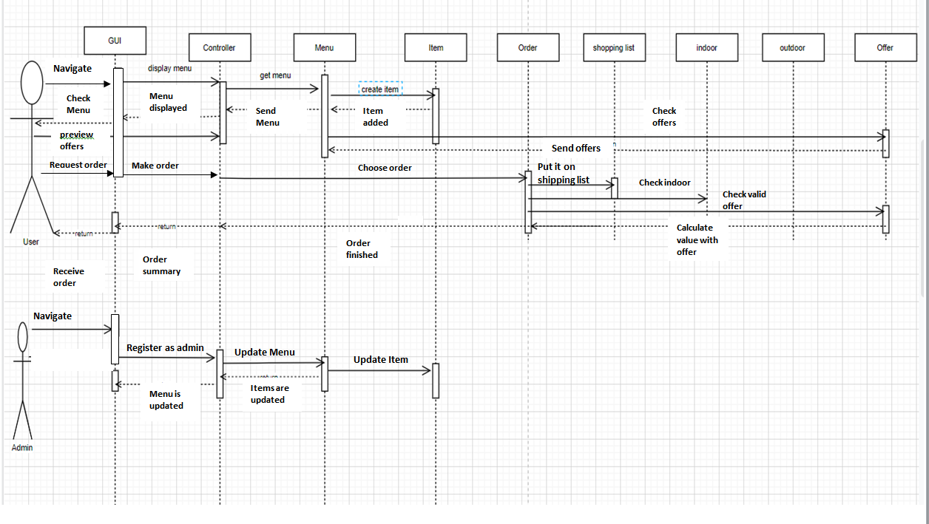

**10. Detailed Class diagram**

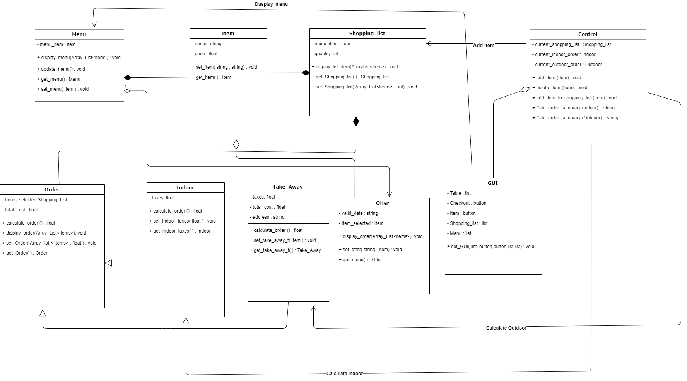

**11. User Interface Design**

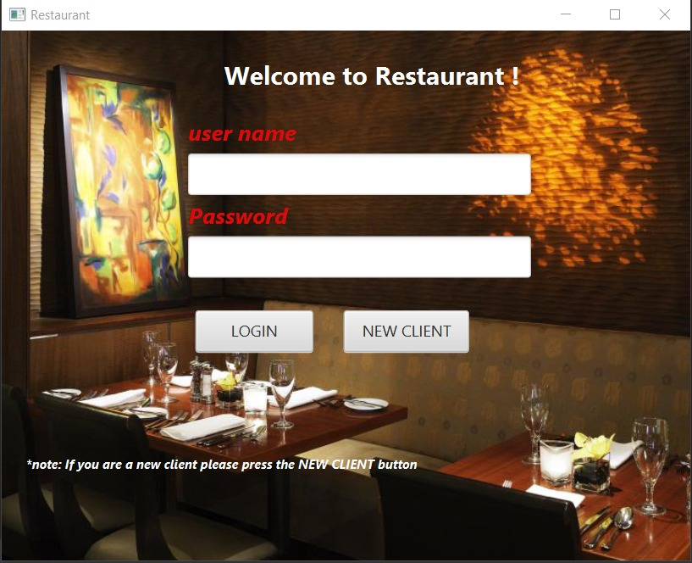1- Admin Login.

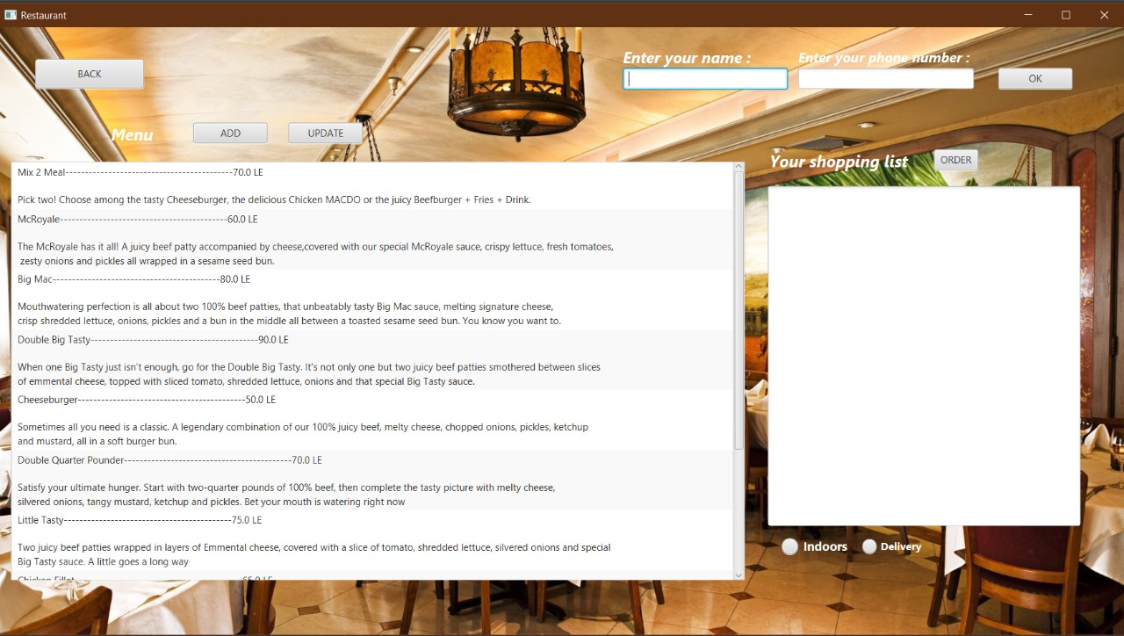2- New Clinet Login.

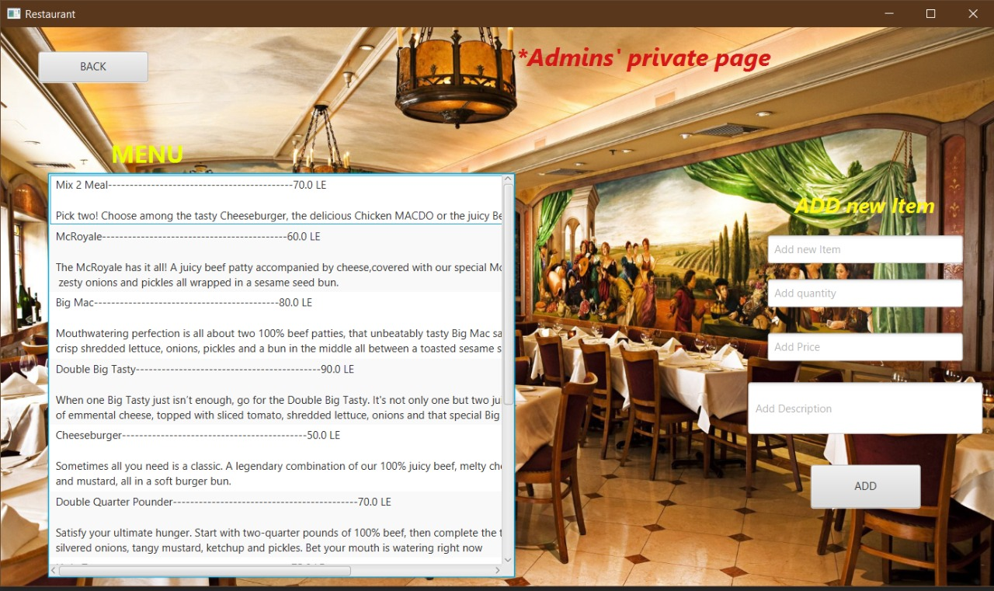3-The Admin can Add New Items to Menu.

4- The User can Select Items From Menu and The Total price shows in the shopping list.

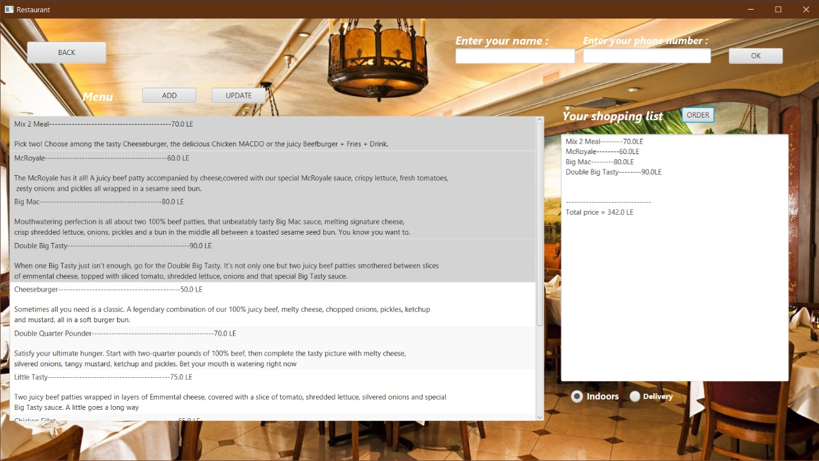

**12. Client- Object Relation Diagram**

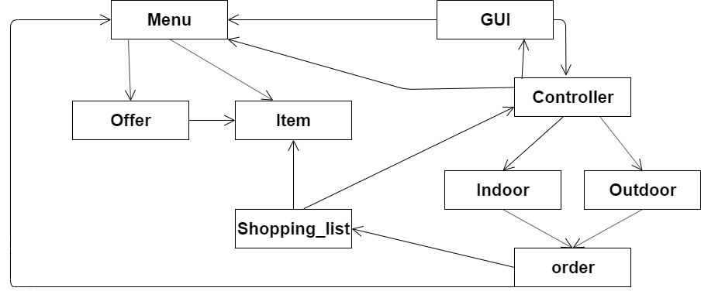

**13. Detailed design**

**PDL Diagram**

Void add_item(item){

Menu.set_item(item);

}

Void delete_item(item)

{

Menu.delete_item(item);

}

Void add_item_to_shopping_list(item){

Shopping_list.set_item(item);

}

String calculate_indoor_summary(indoor){

String indoor_summary ;

Float indoor_total = indoor.calaculate_indoor_order(indoor);

List shopping_list = shopping_list.get_shopping_list();

Indoor_summary = (string) indoor_total ;

For(item I : shopping_list){

Append I to Indoor_summary;

}

Append Table to Indoor_summary ;

Return indoor_summary;

}

String calculate_outdoor_summary(outdoor){

String outdoor_summary ;

Float outdoor_total = outdoor.calaculate_outdoor_order(outdoor);

List shopping_list = shopping_list.get_shopping_list();

outdoor_summary = (string) outdoor_total ;

For(item I : shopping_list){

Append I to outdoor_summary;

}

Append Table to outdoor_summary ;

Return outdoor_summary;

}

Void Display_menu(Array of Items){

Display List of menu items;

}

Void delete_item(item){

Delete item

}

Void Update_menu(item old,item new)

{

delete old;

Add new;

}

Void Set_menu(item item1)

{

add item1;

}

Item Get_menu()

{

return item;

}

Void set_item (string name, string price)

{

add new_item;

}

Item get_item()

{

Return item;

}

Void displayList_item(Array of items)

{

Display shopping_list;

}

Void setShopping_list(Array of items,integer)

{

Create new shipping_list;

}

Shopping_list get_shopping_list()

{

Return new shopping_list;

}

Float calculate_order(shopping_list)

{

Float total = 0;

For ( item I : shopping_list)

{

Total = total + I.price;

}

Return total;}

Void display_order (shopping_list)

{

Diplay order;

}

Void set_order(Shopping_list)

{

Set new order;

}

order get_order()

{

Return order;

}

Float calculate_indoor_order(total_order)

{

Float total_indoor_order = 0;

total=total_order+indoor_taxes;

Return total;

}

Void set_indoor_total( float total_order)

{

Set total_order;

}

float get_indoor_total()

{

return total_order;

}

Float calculate_outdoor_order(total_order)

{

Float total_outdoor_order = 0;

Total_outdoor_order=total_order+outdoortaxes;

Return total;

}

Void set_take_away_total (total_order)

{

Set total_order;

}

takeaway get_indoor_taxes(){

return total;

}

Void display_offer(Array list of offers)

{

Display array of offers;

}

Void set_offer(item item)

{

Change item’s price;

}

Offer get_offer()

{

Return offer;

}

Void set_GUI(list table, button checkout, button item, list shopping_list, list menu)

{

diplay checkout button;

diplay table_list;

For( item i:menu)

{

Set I;

}

If (item is selected)

{

Add item to shopping list;

}

}

**14. Testing**

* Testing the admin signing in correctly if user name and password matches correct admins one then admin can sign in (unit testing)

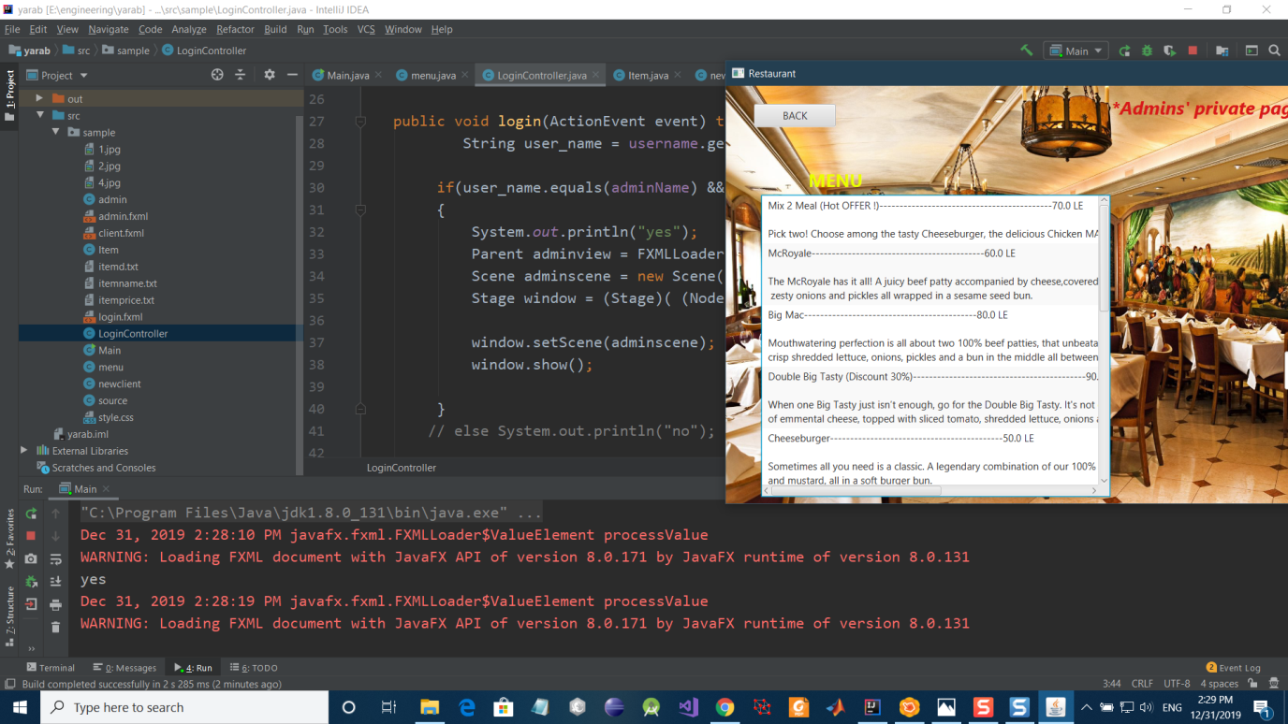

* Testing class menu functions (unit testing)

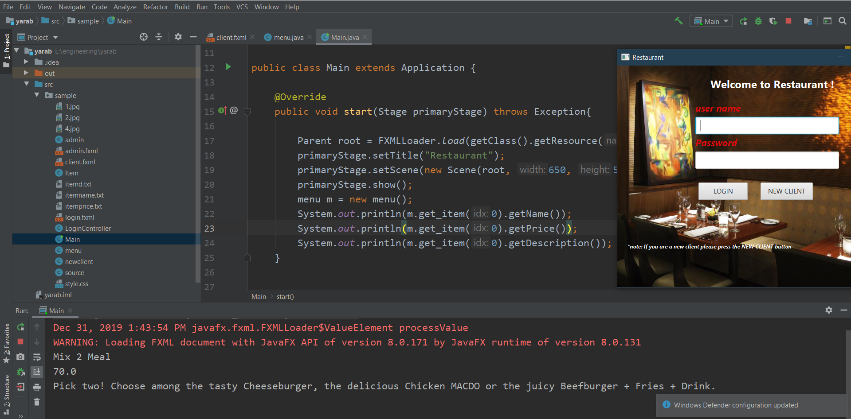

* Testing item class(unit testing)

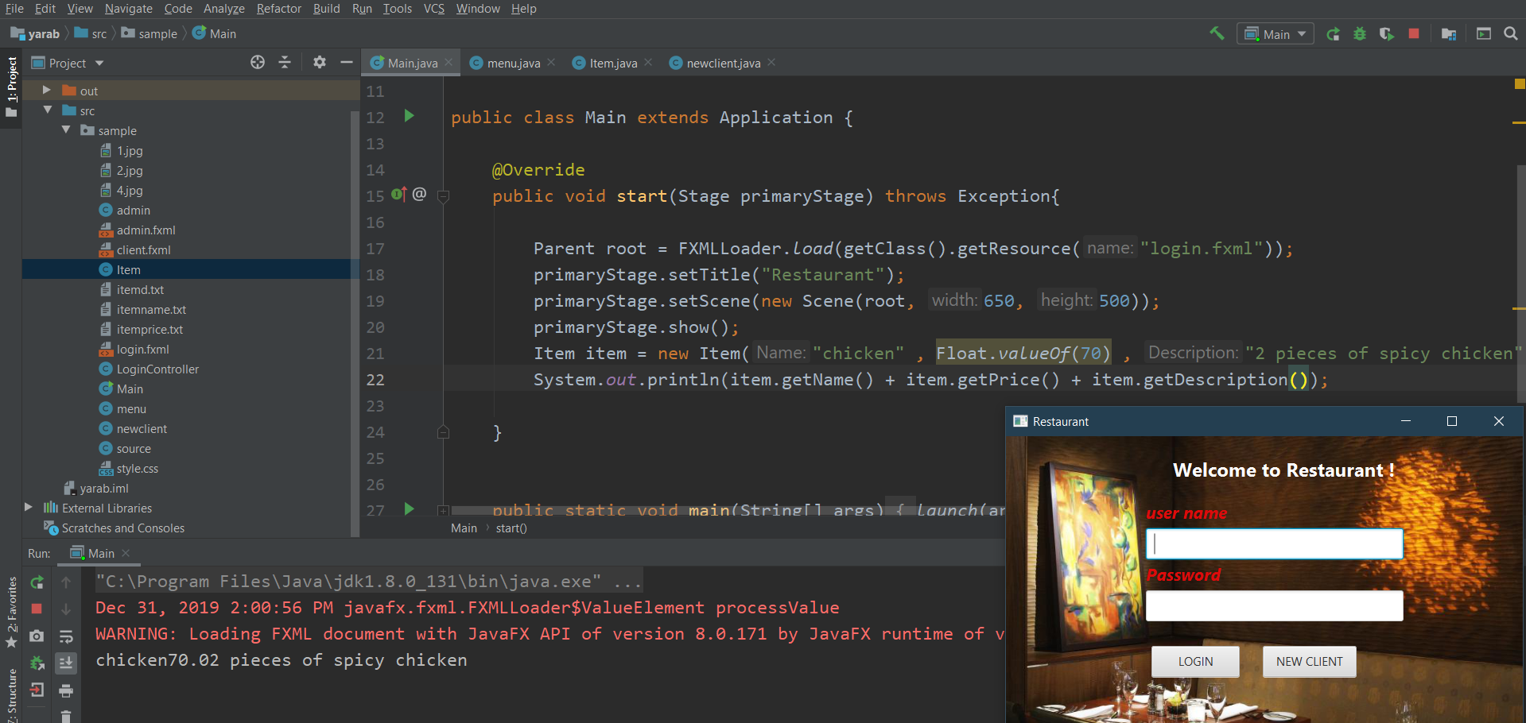

* Testing items added correctly in menu(unit testing)

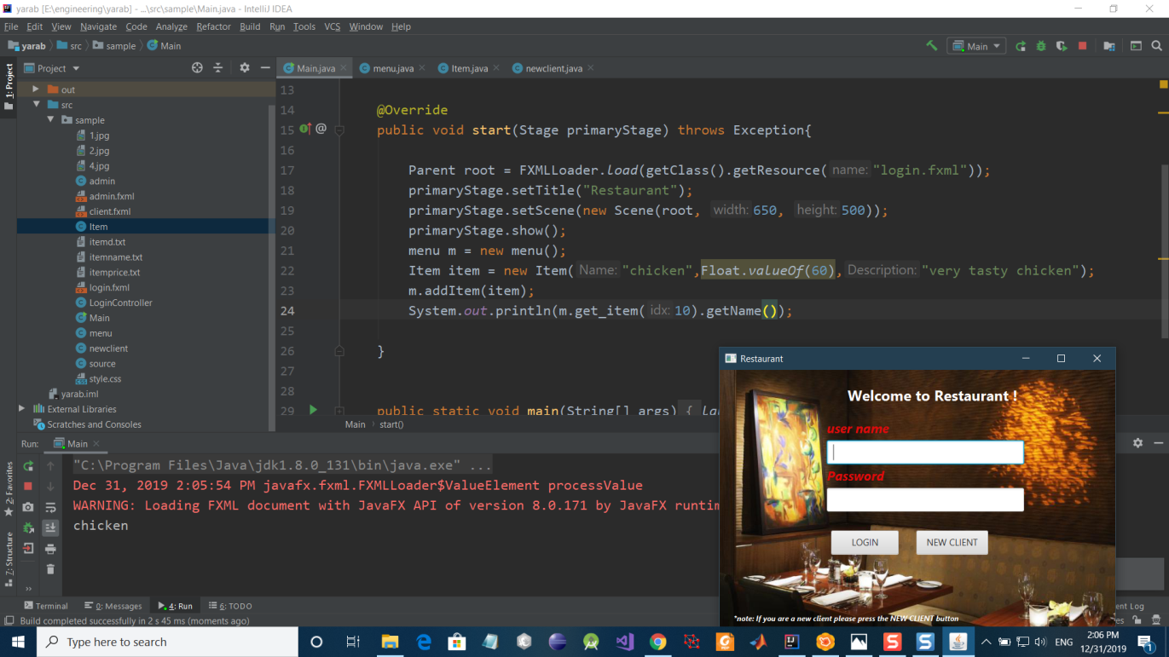

* Testing client button action (system testing)

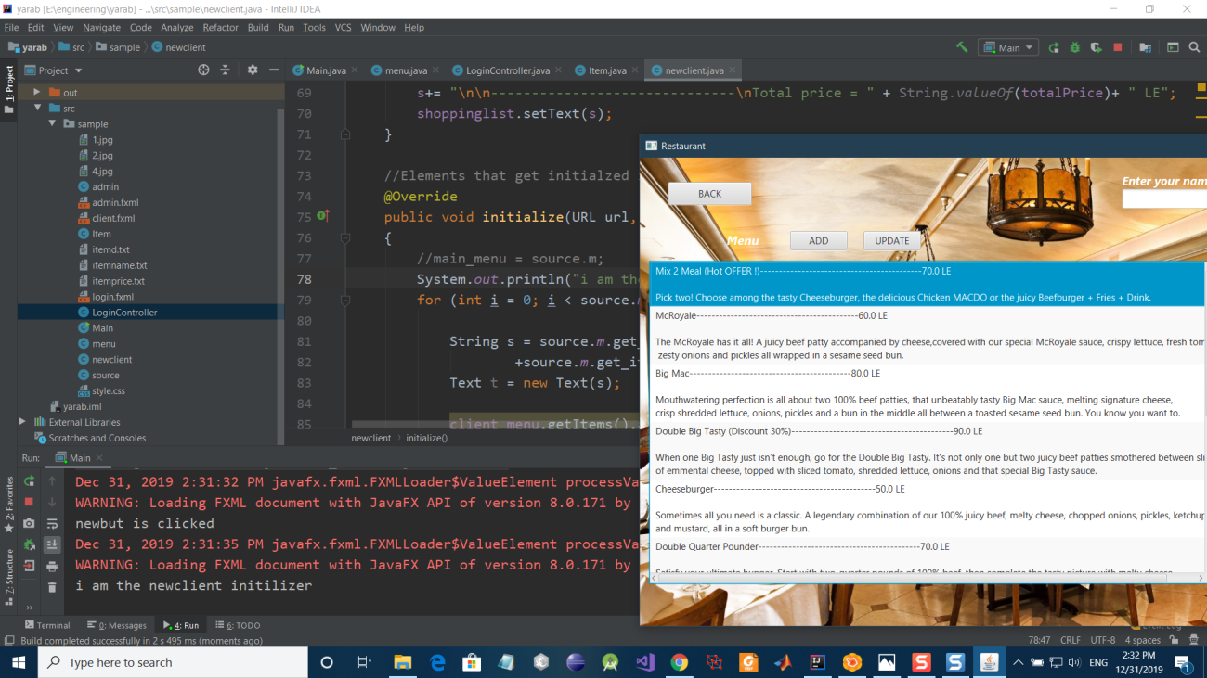

* Testing adding items to shopping list (unit testing)

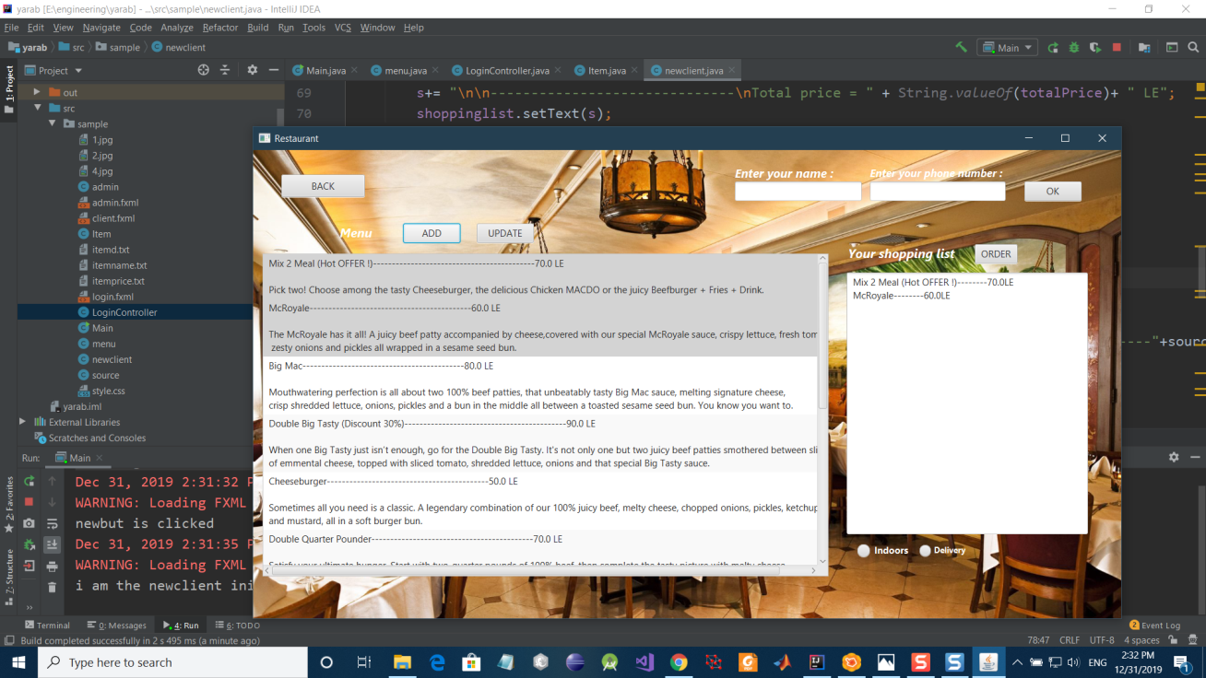

* Testing indoor order calculation after adding taxes to total order(unit testing)

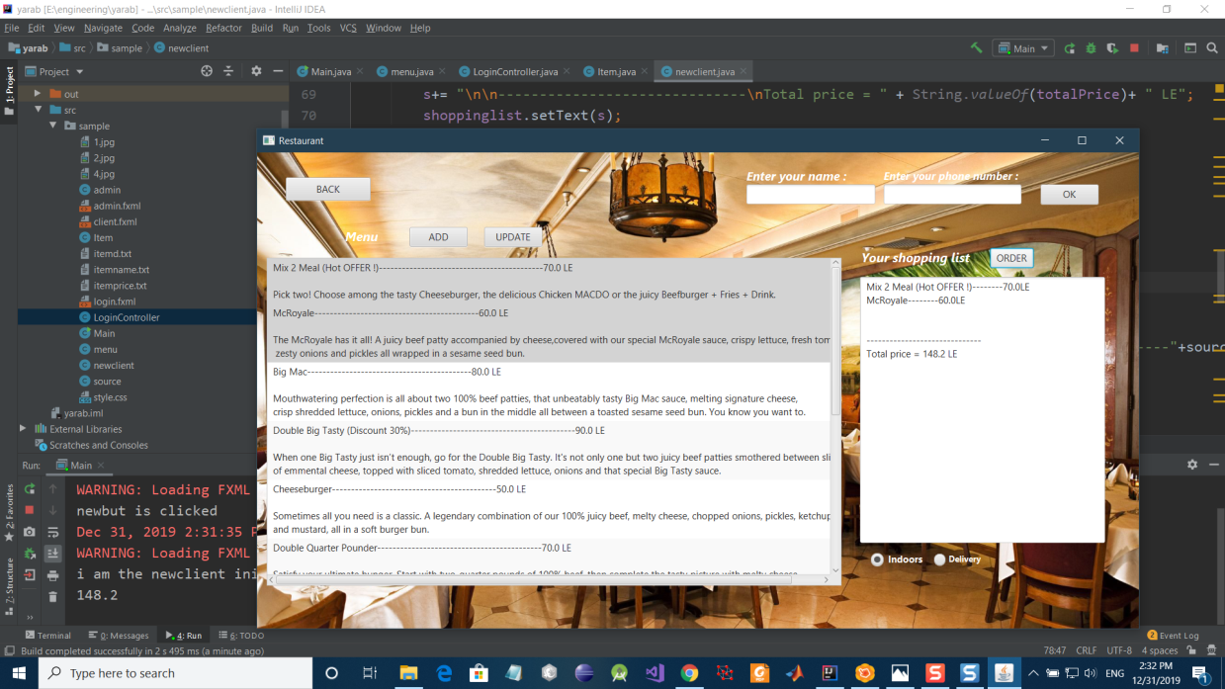

* Testing delivery order after adding taxes and delivery cost to total price(unit testing)

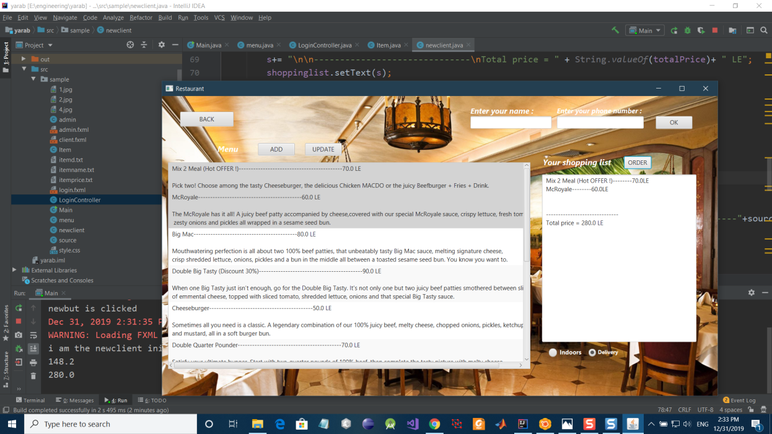

* Testing updating of menu function (unit testing)

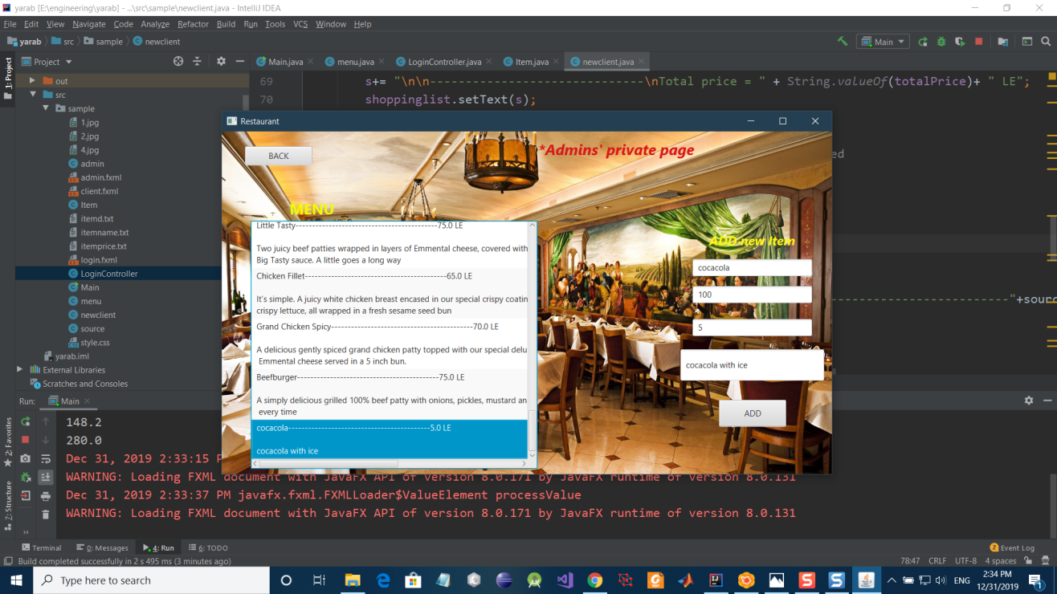

* Testing if menu updated in clients page(system testing)

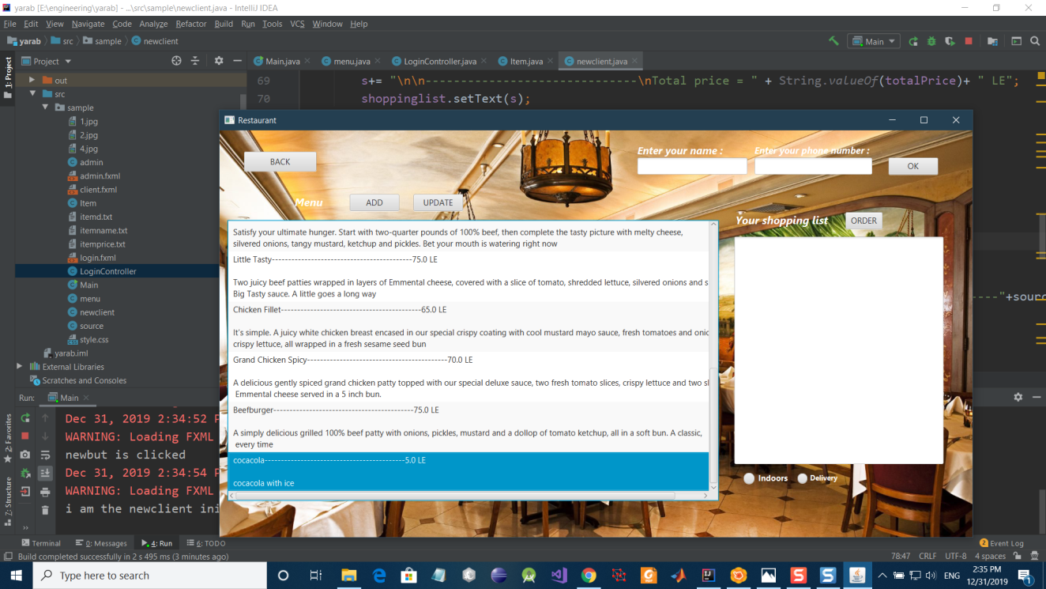

* Testing menu get_size function(unit testing)

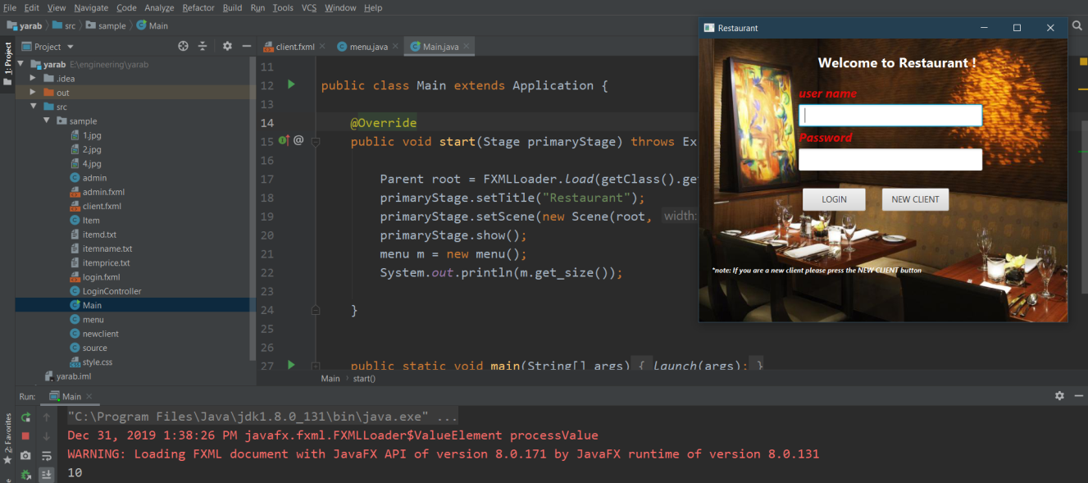

**15. Estimated project cost**

**Cost estimation**

**Application composition method**

( NAP × (1 –(reuse% /100)) )/ productivity

Where : NAP =350 ,reuse% =60% , productivity=6

=24 PM

Cost about 3.5k*24=84kLE

**Early design model**

The estimated cost of the project based on COCOMO-II model

PM= A × (Size )B × M

Where : A = 2.94 , B = 1.2 , Size = 0.8 KLOC

To calculate M

* RCPX = 1.5
* RUSE = 2
* PDIF = 2
* PREX = 1.2
* PERS = 1.2
* SCED = 1
* FCIL = 1

M = RCPX * RUSE * PDIF * PREX * PERS * SCED* FCIL = 8.64

So PM = 20 Person-month

Estimated cost for the project is 3.5k * PM = 70 KLE

**Estimated project cost**

* 1 project manager (5k)
* 1 executive manager (5k)
* 5 developers (20k)
* Hardware and software (15k)

**Effort overhead**

* Office rent (10k)
* Drinks and launch(5k)
* Health and electricity (10k)

Total estimated : cost 70k

Selling price : 100k

**16. User guide**

If you are an admin select username”Admin”,password”Admin”.

Press login.

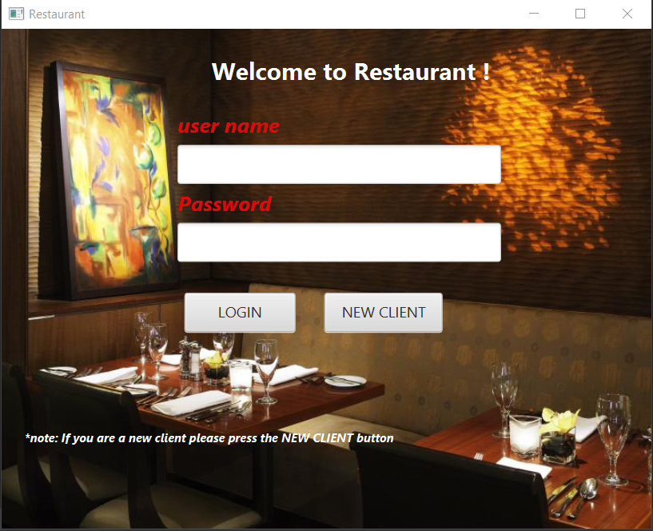

admin

admin

If you logged in as an admin, you can add item and update menu.

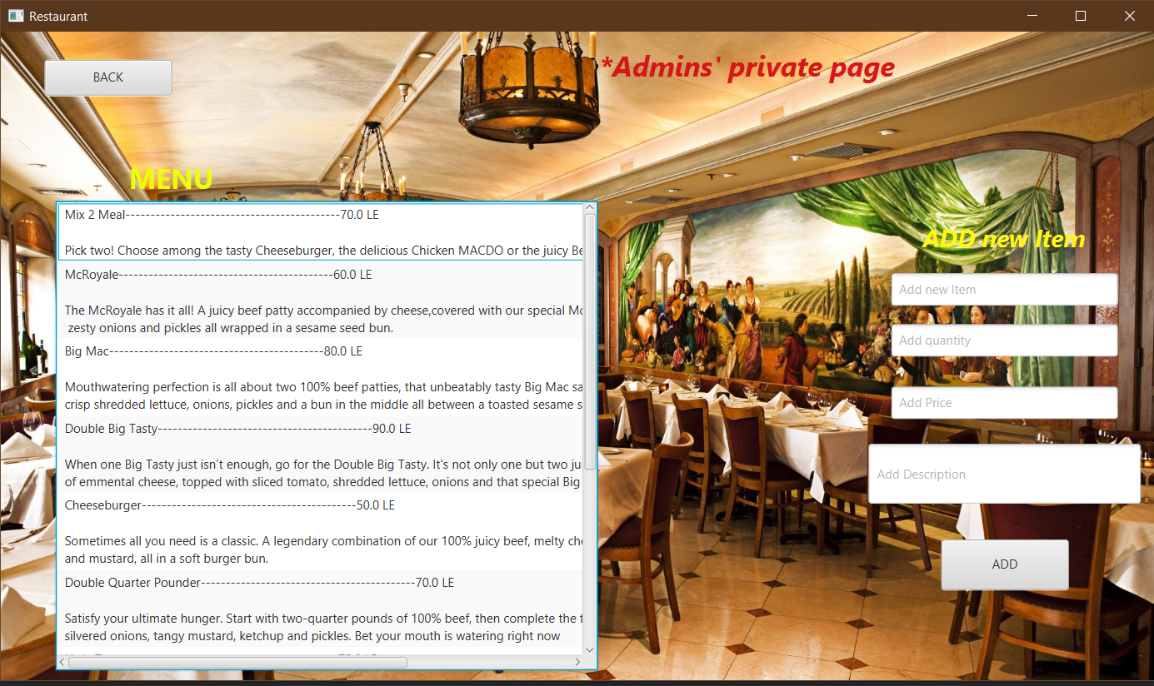

After you selected “new client”: you can see the menu, offers and select your desired items by holding cntrl button and select to add them to the shopping list.

Then you choose your order to be indoor or takeaway then press order.

The order’s summary will appear showing your total cost and the estimated time for your order to be ready, and your table in case of indoor orders.

